Management of the Hot/Swollen Joint
Slide 1
Hot/Swollen Joints
-Common problem
-Managed by:
-Family doctors
-Emergency doctors
-Internists
-Rheumatologists
-Orthopaedic surgeons
-Etc.

[A swollen joint is a condition that every physician will have seen at some stage of training in their career. Management of the hot and swollen joint is often multidisciplinary and includes family doctors, emergency doctors, internists, rheumatologists, and orthopaedic surgeons. Inflammation of the joints, or arthritis, is the one of the most common medical condition in seniors. That being said, there are many different types of arthritis and they can affect younger populations as well. Understanding the general principles in the management of the hot and swollen joint is important because presentations are common and there can be severe consequences if some diagnoses are missed. Although this video will focus on an orthopaedic perspective, particularly in distinguishing the septic joint from the non-septic joint, it is important to remember that depending on the case, management can rely on different specialities.]

Slide 2
Anatomy/Physiology
3 Types
-Fibrous joint
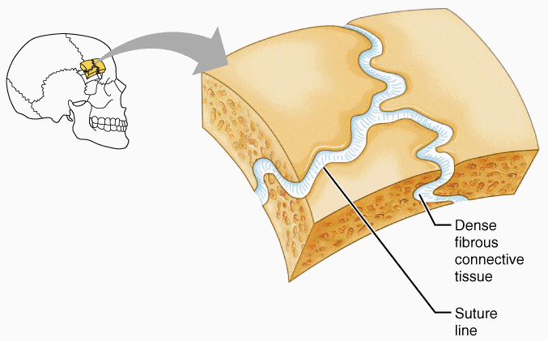

-Cartilaginous joint
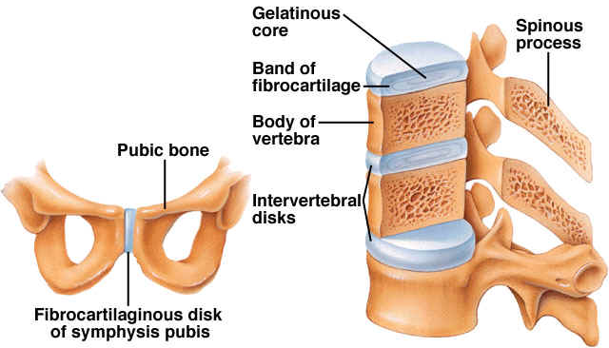

-Synovial joint
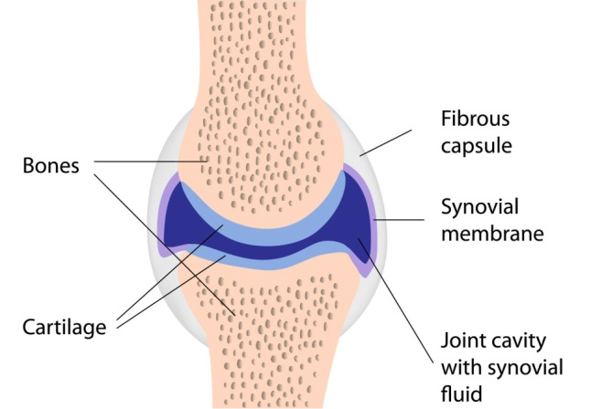

[Overall, there are three types of joints. Fibrous joints are the least mobile and are connected by dense connective tissue, most of which is collagen. Cartilaginous joints are more mobile than fibrous joints and, as their name implies, they are connected by cartilage. Synovial joints are the commonest type of joint in the human body. They are the most mobile of the joints and possess a synovial cavity that surrounds the articulating surfaces of the bones. The cavity is filled with synovial fluid which helps reduce friction in the joint. Synovial joints are of particular concern when it comes to septic arthritis.]

Slide 3
Pathophysiology
-Autoimmune inflammation of synovial membrane
-Infection and inflammation of synovial membrane
-Crystal deposition and inflammatory response
-Degeneration of articular cartilage
-Trauma to general structures

[The mechanism of joint swelling is generally an inflammatory response, but the exact causes differ among the various arthritides. Some examples are provided here.]
[Inflammation of the synovial membrane, or synovitis, is seen in autoimmune arthritides such as rheumatoid arthritis.]
[The synovial membrane also becomes inflamed when the joint is infected, as in the case of septic arthritis. The inflammation in this case is a natural immune response to the pathogen causing the infection. Typically, the offending agents are bacteria introduced either through direct penetration into the joint or dissemination through blood due to a systemic infection.]
[In a case of crystal arthritis such as gout, crystals are deposited in the synovial membrane, cartilage, or elsewhere in the joint. The body mounts an inflammatory response and the joint becomes swollen and painful. The different types of crystal arthritis can be distinguished based on their crystal composition, the joints they affect, and their pattern of deposition.]
[Inflammation can also occur with degeneration of the articular cartilage of the bones in the involved joint. This is called osteoarthritis. Although osteoarthritis is classified as a non-inflammatory arthritis, there is still inflammation occurring and this can lead to the clinical presentation of a swollen joint. Risk factors include age, previous joint trauma, developmental abnormalities, and obesity.]
[Trauma to the joint can result in swelling and heat. To list a few, joint trauma includes bursitis, ligament and cartilage tears, and fractures. In severe cases, bleeding can occur in the joint and this is known as haemarthrosis. Haemarthrosis can also occur in patients with bleeding disorders. It is important to remember that trauma can provide a direct route for inoculation of bacteria into the joint, which may lead to septic arthritis.]

Slide 4
General Approach
Wide differential for a hot/swollen joint:
-Septic arthritis
-Crystal arthritis
-Rheumatoid arthritis
-Reactive arthritis
-Trauma
-Bursitis
-Haemarthrosis
-Cellulitis
-Osteoarthritis
-Etc.

[When a patient presents with a hot and swollen joint, there is a wide differential. For causes of an acute presentation, septic arthritis is the most dangerous and crystal arthritis is the most common. After taking a history, one should be able to narrow down the possible diagnoses and proceed with appropriate diagnostics. An important point to remember is that bursitis does not have to occur from overt trauma. Recurrent irritation of the bursa through joint overuse and infection are examples of other causes of bursitis. If septic bursitis is suspected and septic arthritis is ruled out, joint aspiration should be avoided due to the risks of introducing infection into the joint. Also note that a general inflammation around the joint with overlying redness could be a cellulitis.]

Slide 5
General Approach
Investigations:
-Physical exam
-Observation (SEADS)
-Palpation (warmth, fluctuance, tenderness, etc)
-ROM (active and passive)
-Weight bearing tolerance

[Remember that the medical history is key to guiding choice of investigations for a hot and swollen joint. Some investigations and their benefits will be discussed.]
[The physical exam should be done first. A good initial approach is to observe using the SEADS approach. This includes examining for joint swelling, effusions, erythema, atrophy, skin deformities, and skin changes.]
[Palpate the affected joint while ensuring the patient is comfortable. Things to note include warmth, fluctuance, and tenderness. Fluctuance is the wave-like feeling when palpating an area of skin overlying an effusion. Depending on severity, effusions can also be detected with ballottement and patellar tap tests.]
[Evaluate the range of motion of the joint. Limitation in both active and passive range of motion is expected with any large effusions. A severe restriction in movement warrants a more urgent approach.]
[Have the patient stand up and take some steps to assess weight bearing tolerance. Note if the patient is experiencing pain.]

Slide 6
Arthrocentesis (Joint Aspiration)
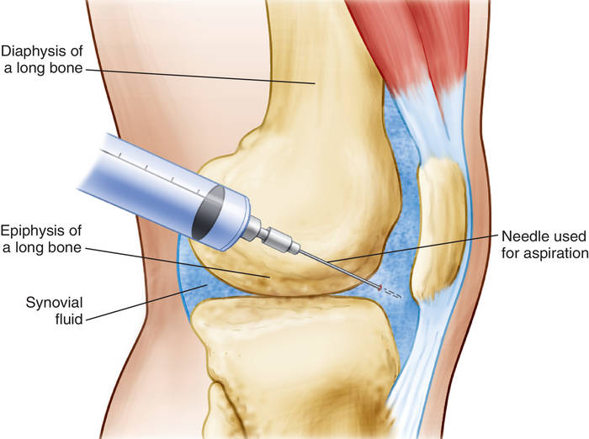
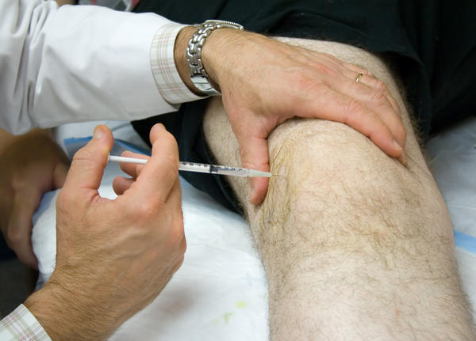

[Synovial fluid sampling provides useful diagnostic information. For example, in the case of septic arthritis, the fluid which is normally sterile may test positive for bacteria. Synovial fluid is extracted by arthrocentesis, also known as joint aspiration. This technique involves carefully inserting a needle into the synovial cavity and taking appropriate samples. Arthrocentesis can also be used to drain fluid or inject medications into the synovial joint as needed.]

Slide 7
General Approach
Labs:
-Synovial fluid analysis
-Gram stain and culture for septic arthritis
-Compensated polarizing microscope for crystal arthritis

[The appearance and viscosity of the synovial fluid and subsequent lab analysis can help determine if there is bleeding, immune mediated inflammation, crystal arthritis, or septic arthritis. In cases of septic arthritis, Gram staining and culturing are important to adjust treatment later. However, antibiotics should not be delayed for when lab results return. If crystal arthritis is suspected based on history and physical exam, compensated polarizing microscopy will help confirm the type of crystal arthritis.]

Slide 8
General Approach
Imaging:
-X-ray
-Ultrasound
-MRI

[Imaging can also aid in the work-up. For example, X-rays are useful for identifying any obvious trauma such as fractured bones around the joint. Ultrasound can be used to evaluate soft tissue swelling as in the case of cellulitis, or to investigate possible abscesses. MRI can be useful for investigating deeper structures for abscesses and osteomyelitis.]

Slide 9
Gout
-Common cause of an acute hot and swollen joint
-Urate crystals
-In primary care, commonest affected joint is the great toe metatarsophalangeal
-Diagnosed clinically
-Family history

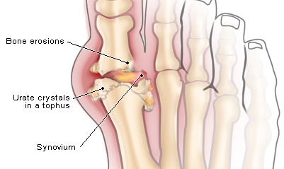

[Some brief details on gout are included here because of how common the presentation is in the context of inflamed joints. Gout is a crystal arthritis where urate crystals deposit in the affected joint and inflammation and pain results. Another form of crystal arthritis is pseudogout, in which the crystal is calcium pyrophosphate. If a patient presents with an acute hot and swollen joint, particularly a male, the most likely diagnosis is gout. Women become more susceptible to gout after menopause. In visits to family doctors and other primary care providers, the great toe metatarsophalangeal joint is most commonly affected. There are several risk factors for gout, but it is important to emphasize family history. Family history of gout should be easy to elicit and any findings should increase suspicions. In summary, gout can be diagnosed clinically based on history and physical examination alone. If necessary, microscopic examination of a joint aspiration can confirm the diagnosis.]

Slide 10
Treatment of Non-Infectious Cases
-Anti-inflammatories
-Check renal function
-Corticosteroids for crystal arthritis
-Should NOT be used in suspected septic arthritis and other septic cases

[In most cases of swollen joints due to non-septic causes, the treatment regimen includes anti-inflammatories. Remember that it is important to assess renal function when prescribing NSAIDs. For crystal arthritis, corticosteroids can also be used. Note that if there is clinical suspicion for suspected septic arthritis, corticosteroids should not be administered.]

Slide 11
Septic Arthritis
Why is it a big deal?
-Most urgent
-Sepsis, joint damage, death
-Significant mortality and morbidity
-Mortality around 10%
-Do not miss it!

[A major concern for physicians, especially orthopaedic surgeons, is whether or not a joint is septic. Though not a common cause of a hot and swollen joint, septic arthritis is the most urgent. Bacteriaemia, sepsis, osteomyelitis, joint damage, and even death are some examples of the consequences of untreated septic arthritis. Because mortality is around 10%, this is the most severe cause of a hot and swollen joint. It is a diagnosis that should not be missed.]

Slide 12
Septic Arthritis
Typical Presentation
-1-2 week history of pain, swelling, tenderness, heat, restricted movement in affected joint
-Acute presentation also possible
-Can affect more than one joint
-Redness of overlying skin
-Large joints > small joints
-Knee, hip
-Absence of trauma
-Febrile
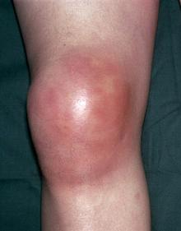

[A typical presentation of septic arthritis is a one to two week history of pain, swelling, tenderness, heat, and restricted movement in the affected joint. Symptoms tend to be more severe than aseptic cases that have similar presentations. Until proven otherwise, treat this as a septic arthritis case. Keep in mind that while the typical presentation is a one to two week history, patients can also present more acutely. One may think that septic arthritis is monoarticular but in almost a quarter of cases it can present in a polyarticular fashion. There may also be redness of the skin overlying the joint. Septic arthritis tends to affect larger joints more than smaller joints. In over half of septic arthritis cases, the knee or the hip is involved. If trauma is ruled out as a possible cause, this increases the clinical suspicion for septic arthritis. If the patient is febrile, proceed with antibiotic therapy after arthrocentesis. Note that if the patient does not have a fever, but there is still clinical suspicion of septic arthritis, it is advisable to proceed with antibiotics after arthrocentesis anyways.]

Slide 13
Septic Arthritis
Causes
-Hematogenous spread
-Direct invasion
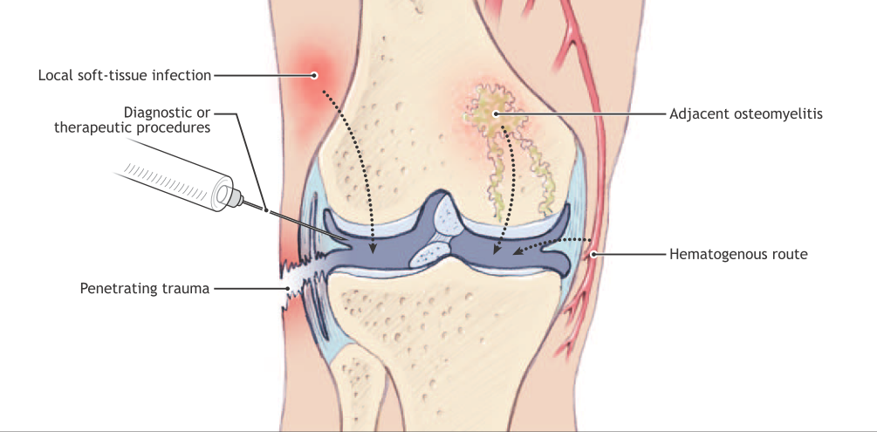

[Septic arthritis is caused by bacteria infiltrating the normally sterile joint space. This can occur through hematogenous spread, which is more common, or direct invasion, which includes penetrating trauma, iatrogenic procedures, and spreading of overlying cellulitis and adjacent osteomyelitis. Hematogenous spread is more common because the synovial membrane is well vascularized and this provides a route of access to the synovial space.]

Slide 14
Septic Arthritis
Risk Factors
-Underlying degenerative or inflammatory arthritis
-Joint prostheses
-Immunosuppression
-Age
-IV drug use
-Iatrogenic
-Alcohol
-Diabetes

[Included here are several risk factors for developing septic arthritis.]
[Underlying joint disease is the biggest risk factor for septic arthritis. Structurally abnormal joints are naturally at a higher risk of infection. This does make diagnosis tricky in patients with a concurrent chronic arthritis, but as mentioned before, septic arthritis typically has more severe symptoms compared to non-septic arthritic joints and this helps distinguish it from underlying arthritis. Remember that patients with rheumatoid arthritis are more prone to septic arthritis not only because of the structural damage to their joints but also because of the immunosuppressive treatment they would be undergoing.]
[Having a joint prosthesis increases the risk of joint infection. For example, coagulase-negative Staphylococci which are atypical for native joint infections can thrive in prosthetic joints.]
[Similarly, immunosuppression can result in atypical bacteria becoming causative agents. Immunosuppression in septic arthritis patients also risks sepsis, hence why corticosteroids are contraindicated in suspected septic arthritis cases.]
[Patients at either extremity of the age spectrum are at an increased risk due to having weaker immune systems. However, it is important to remember that septic arthritis can affect any age group.]
[Use of intravenous drugs risks septicaemia through direct inoculation of bacteria into the blood stream, especially with unsterilized needles.]
[Contamination also plays a role in iatrogenic causes. Due to the recent increase in intra-articular procedures, these interventions are becoming more relevant as risk factors.]
[Alcohol and diabetes are also risk factors.]

Slide 15
Septic Arthritis
Investigations
-Rapid diagnosis and prompt sampling is key
-Physical Exam
-Assess range of motion
-Look for joint effusion
-Synovial fluid sampling BEFORE antibiotic therapy
-Microscopic analysis and culture of synovial fluid
-Negative result does not rule out infection!
-Refer suspected infected prosthetic joint to orthopaedic surgeon for aspiration

[Remember that in septic arthritis cases, rapid diagnosis is crucial. Irreversible joint damage is a consequence of delay. However, quick treatment is not a guarantee that there will be no joint damage. Even with a prompt response, some patients will suffer joint damage and rarely septicaemia.]
[On the physical exam, severely restricted motion of the joint along with presence of a joint effusion increases clinical suspicion.]
[Performing an arthrocentesis to obtain a synovial fluid sample is the gold standard for diagnosis of septic arthritis. Synovial fluid samples are also extremely helpful in management of septic arthritis, especially to narrow antimicrobial coverage after empiric therapy. Always aspirate the affected joint prior to initiating antibiotic therapy to minimize false negative results on microscopy and Gram staining.]
[Microscopic analysis and culturing of the synovial fluid has a sensitivity of around 50%, meaning a positive result from Gram staining and microscopy only occurs in half the septic cases. Detection can be improved by repeating the lab testing but it is important to remember that negative microscopies and cultures do not rule out septic arthritis as a possible cause of the swollen joint.]
[In the case of a prosthetic joint that is possibly infected, call an orthopaedic surgeon to conduct the aspiration.]

Slide 16
Septic Arthritis
Investigations
-Blood culture
-WCC, ESR, CRP
-X-ray, ultrasound
-Assess renal and liver function
-MRI for osteomyelitis

[A blood culture should be done to look for septicaemia. Other tests useful for septic arthritis are white cell count, erythrocyte sedimentation rate, and C-reactive protein levels. However, since these diagnostics are not perfectly sensitive or specific, they should not be solely relied on in making a diagnosis. When interpreting test results, always use clinical judgment.]
[Even though X-rays of the joint is of minimal value in septic arthritis cases, imaging is quick and easy and will be useful for non-septic causes of a hot and swollen joint, particularly chondrocalcinosis, also known as pseudogout. Ultrasounds are useful for evaluating joint effusions, but they are rarely done with the exception of the hip.]
[Remember to assess renal and liver function. If there is end-organ damage resulting in impairment of renal function, some antibiotics may not be suitable.]
[MRIs are not really used in suspected septic arthritis cases unless there is a failure to improve with pharmacological treatment. In such a situation, an MRI of the joint may be necessary to look for osteomyelitis. In these cases, surgical intervention is necessary.]

Slide 17
Arthrocentesis in Possible Cellulitis Cases
-Avoid areas of cellulitis when aspirating
-However, cellulitis and anticoagulation are NOT absolute contraindications

[It should be noted that neither cellulitis nor anticoagulation are absolute contraindications for joint aspiration. When possible, avoid areas of cellulitis when planning an intra-articular route. If access to the joint is not feasible otherwise and there is clinical suspicion for septic arthritis, proceed with aspiration regardless. The risks of inoculating bacteria into the joint and causing septic arthritis is outweighed by the risks of missing and not treating a case of septic arthritis.]

Slide 18
Treatment of Septic Arthritis
Pathogen
-Gram-positive: Staphylococcus and Streptococcus account for 91%
-Gram-negative bacilli
-Elderly, immunocompromised, recently catheterized

[The vast majority of septic arthritis cases are due to Staphylococcus and Streptococcus bacteria. That being said, if the patient is elderly, immunocompromised, or has recently undergone a procedure such as insertion of a central line or a urinary catheter, Gram-negative bacilli should be strongly considered as the causative organism.]

Slide 19
Treatment of Septic Arthritis
-Prompt treatment is key
-Bactericidal activity against Staphylococcus aureus and Streptococci
-Confirmed case: IV antibiotics
Gram-positive bacteria
-Community acquired infections: Cefazolin (Ancef)
-Nosocomial infections: Vancomycin
Gram-negative bacteria
-Third generation cephalosporin
-Pseudomonas aeruginosa: ceftazidime and gentamycin
-Suspected case: Basic regimen could be 2 weeks IV or until improvement, then 4 weeks oral
-Drain joint, remove pus
-Arthroscopy
-Serial needle aspiration
-(Corticosteroid treatment)
-If hip sepsis is suspected, image guided aspirate and urgent referral to an orthopaedic surgeon

[Prompt treatment is key. If there is suspicion of septic arthritis, initiate antibiotics after taking the synovial sample. When the lab results come back, the treatment can be adjusted as necessary. At minimal, the initial antibiotic should have bactericidal activity against Staphylococcus aureus and Streptococci but remember to still use clinical judgment in choice of antibiotic. Account for local demographics and consult with Infectious Diseases to ensure the proper regimen.]
[Septic arthritis confirmed with aspirate is treated with intravenous antibiotics initially. Start with Cefazolin, also known as Ancef, unless there is a definite suspicion of another pathogen. For nosocomial infections, vancomycin is a good choice. If Gram staining reveals Gram-negative bacteria, use a third generation cephalosporin. If Pseudomonas infection is suspected, double coverage with ceftazidime and gentamycin is recommended.]
[For suspected septic arthritis, a possible treatment plan is intravenous antibiotics for 2 weeks or until improvement, followed by 4 weeks of oral antibiotics. This is a guideline and it is recommended to adjust treatment based on patient responses and outcomes.]
[Draining of the affected septic joint to remove pus is also done to reduce pressure in the joint. This relieves symptoms, improves joint mobility, and improves recovery. Arthroscopy and serial needle aspiration both work for draining of the joint. Neither has been proven to be superior to the other.]
[Even though corticosteroids are contraindicated in septic arthritis cases, especially as monotherapy, there may be benefit in complementing antimicrobial treatment with dexamethasone. Some studies in humans have demonstrated improvement in recovery and reduction of joint damage with adjunct dexamethasone therapy for septic arthritis. This suggests that there is an immune-mediated component contributing to joint damage in these cases.]
[Finally, if an infected hip joint is suspected, patients require an image guided aspirate by radiology to confirm the diagnosis. Refer to an orthopaedic surgeon as soon as possible. In cases of septic hip joints, open debridement may be considered by the orthopaedic surgeon.]

Slide 20
Conclusion
Management of the hot and swollen joint
-Distinguish between septic and non-septic cases
-Use clinical suspicion
-Do not rely solely on lab results
-For suspected septic cases:
-Arthrocentesis
-Initiate antibiotic therapy
-Drain joint

[This has been an overview of how to manage the hot and swollen joint. Remember that due to the urgency of septic arthritis, the priority should be to distinguish septic from non-septic cases. Always use clinical suspicion and do not rely exclusively on lab results to make diagnoses. Absence of fever, normal white blood cell count, normal erythrocyte sedimentation rate, normal C reactive protein do not exclude the diagnosis of septic arthritis alone. Arthrocentesis, or joint aspiration, is very useful for confirmation of septic arthritis and crystal arthritis. In suspected septic cases, aspirate the joint first and then initiate general antibiotic therapy while lab diagnostics are performed. The regimen of antibiotics can be adjusted later based on culture and Gram-staining results. Arthrocentesis can also be performed to drain the septic joint to provide relief and improve outcomes.]

Slide 21
References
“BSR & BHPR, BOA, RCGP and BSAC guidelines for management of the hot swollen joint in adults” (Coakley G. et. al) Rheumatology. 2006;45(8):1039–1041

“Clinical Management of Septic Arthritis” (Sharff K.A, Richards E.P, Townes J.M) Current Rheumatology Reports. 2013 Jun;15(6):332

“Guideline for the management of the hot swollen joint in adults with a particular focus on septic arthritis” (Weston V. et al) The Journal of Antimicrobial Chemotherapy. 2006 Sep;58(3):492-3.

“Joint Aspiration and Injection: A Look at the Basics” (Baker K, O'Rourke S, Deodhar A) Rheumatology Network. June 07, 2011. Web.

“Management of the nontraumatic hot swollen joint” (Reed M.J, Carachi A) European Journal of Emergency Medicine. 2012 Apr;19(2):103-7.

“Septic arthritis: current diagnostic and therapeutic algorithm” (Mathews C.J, Coakley G) Current Opinion in Rheumatology. 2008 Jul;20(4):457-62.

“Septic arthritis in patients with pre-existing inflammatory arthritis” (Kherani R.B, Shojania K) Canadian Medical Association Journal. 2007 May;176(11):1605-1608.

“The Approach to the Painful Joint” (Baer, A.N) Medscape. January 23, 2014. Web.

Images
HumanAnatomy. <http://humananatomy.co/wp-content/uploads/2016/08/fibrous-joints-types-of-synovial-joints.gif>
Interactive Biology. <http://interactive-biology.com/wp-content/uploads/2012/06/Synovial-Joint_2-963x1024.jpg>
Southwest Tennessee Community College. <http://faculty.southwest.tn.edu/rburkett/A&P1_a15.jpg>
HealthTap. <https://edc2.healthtap.com/ht-staging/user_answer/reference_image/11416/large/knee_arthrocentesis.jpeg?1386671175>
Medical Dictionary. <http://img.tfd.com/medical/Davis/Tabers/a45.jpg>
MedicineNet. <http://resourcedirectory.tripod.com/gout.jpg>
Natural Health News. <http://www.natural-health-news.com/wp-content/uploads/2015/01/Septic-Arthritis.jpg>
Canadian Medical Association Journal. <http://www.cmaj.ca/content/176/11/1605/F2.medium.gif>

